# Отчет за 3 и 4 Лабораторные работы

Текст задания:

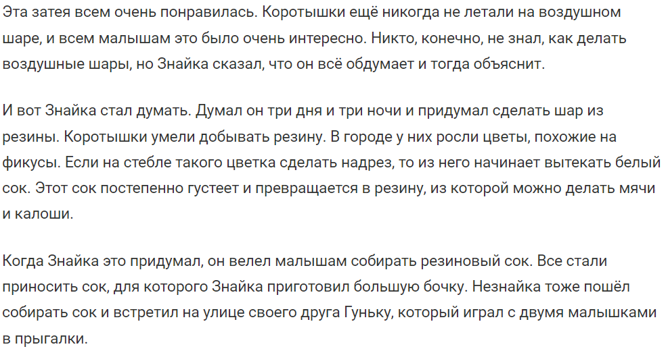

Диаграмма классов:

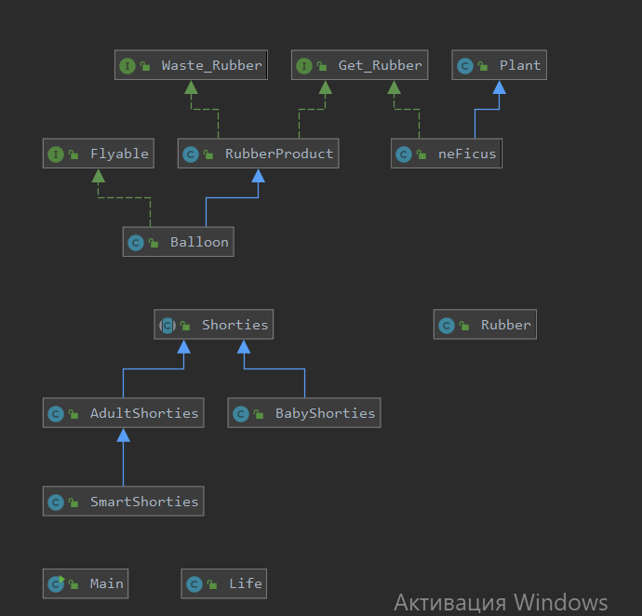

Исходный код программы:

//Скинула архив на почту

Результат работы программы:

Leader of Shorties -> Znayka: Status = THINK

Neznayka: Status = NOTHING

Gunka: Status = NOTHING

Baby: Status = NOTHING

Plants:

class neFicus: size = 1, amount of juice = 0.39805219005019954

class neFicus: size = 1, amount of juice = 0.5770512952725972

class neFicus: size = 1, amount of juice = 0.35630355332067376

class neFicus: size = 1, amount of juice = 0.03592989136082103

class neFicus: size = 1, amount of juice = 0.018510526185092857

Keg: V = 0.0, k = 0.0

Резины не достаточно :(

Leader of Shorties -> Znayka: Status = COMMAND

Neznayka: Status = COLLECT_JUICE

Gunka: Status = COLLECT_JUICE

Baby: Status = COLLECT_JUICE

Plants:

class neFicus: size = 2, amount of juice = 1.7521991988004189

class neFicus: size = 2, amount of juice = 0.9137892780149472

class neFicus: size = 2, amount of juice = 0.414815138850009

class neFicus: size = 2, amount of juice = 0.8634903471558115

class neFicus: size = 2, amount of juice = 0.1499971209213169

Keg: V = 1.6081810948268964, k = 0.1

Резины не достаточно :(

Leader of Shorties -> Znayka: Status = COMMAND

Neznayka: Status = COLLECT_JUICE

Gunka: Status = COLLECT_JUICE

Baby: Status = COLLECT_JUICE

Plants:

class neFicus: size = 2, amount of juice = 1.7153284798887596

class neFicus: size = 2, amount of juice = 1.4451296481619136

class neFicus: size = 2, amount of juice = 1.3462154027847062

class neFicus: size = 2, amount of juice = 0.9265949832872413

class neFicus: size = 3, amount of juice = 0.2141391570131601

Keg: V = 7.570508517388139, k = 0.12124270900869057

Резины не достаточно :(

Leader of Shorties -> Znayka: Status = COMMAND

Neznayka: Status = COLLECT_JUICE

Gunka: Status = COLLECT_JUICE

Baby: Status = COLLECT_JUICE

Plants:

class neFicus: size = 3, amount of juice = 1.8540096617855895

class neFicus: size = 2, amount of juice = 1.9016987052567436

class neFicus: size = 2, amount of juice = 1.5612972446005382

class neFicus: size = 3, amount of juice = 1.0888460208403483

class neFicus: size = 3, amount of juice = 1.8477759482542855

Keg: V = 10.0379455555963, k = 0.19143992225677875

Резины не достаточно :(

Leader of Shorties -> Znayka: Status = COMMAND

Neznayka: Status = COLLECT_JUICE

Gunka: Status = COLLECT_JUICE

Baby: Status = COLLECT_JUICE

Plants:

class neFicus: size = 4, amount of juice = 1.8458980111358254

class neFicus: size = 3, amount of juice = 1.8825577094095838

class neFicus: size = 2, amount of juice = 0.9461184515720933

class neFicus: size = 3, amount of juice = 1.4662292903535497

class neFicus: size = 4, amount of juice = 1.5602789642861785

Keg: V = 17.028485370782157, k = 0.21284993790923798

Резины не достаточно :(

Leader of Shorties -> Znayka: Status = COMMAND

Neznayka: Status = COLLECT_JUICE

Gunka: Status = COLLECT_JUICE

Baby: Status = COLLECT_JUICE

Plants:

class neFicus: size = 5, amount of juice = 1.8423018687556045

class neFicus: size = 4, amount of juice = 0.8227342263379958

class neFicus: size = 3, amount of juice = 0.9616768384993243

class neFicus: size = 3, amount of juice = 1.8872866601456417

class neFicus: size = 5, amount of juice = 1.8305325470598386

Keg: V = 24.000903451848785, k = 0.2510156507704361

Резины не достаточно :(

Leader of Shorties -> Znayka: Status = COMMAND

Neznayka: Status = COLLECT_JUICE

Gunka: Status = COLLECT_JUICE

Baby: Status = COLLECT_JUICE

Plants:

class neFicus: size = 6, amount of juice = 2.8358962304347273

class neFicus: size = 4, amount of juice = 1.6428537320201486

class neFicus: size = 4, amount of juice = 1.8493291654219695

class neFicus: size = 4, amount of juice = 1.2575666732789468

class neFicus: size = 6, amount of juice = 0.9528997064294022

Keg: V = 34.12235010209226, k = 0.27655883551452165

Резины не достаточно :(

Leader of Shorties -> Znayka: Status = COMMAND

Neznayka: Status = COLLECT_JUICE

Gunka: Status = COLLECT_JUICE

Baby: Status = COLLECT_JUICE

Plants:

class neFicus: size = 6, amount of juice = 3.573776723161699

class neFicus: size = 5, amount of juice = 1.8175345019040856

class neFicus: size = 5, amount of juice = 1.5104362827447395

class neFicus: size = 4, amount of juice = 2.062129719317553

class neFicus: size = 7, amount of juice = 1.5227997010369647

Keg: V = 40.77660755476787, k = 0.3314277222934412

Резины не достаточно :(

Leader of Shorties -> Znayka: Status = COMMAND

Neznayka: Status = NOTHING

Gunka: Status = NOTHING

Baby: Status = NOTHING

Plants:

class neFicus: size = 7, amount of juice = 4.749702745842034

class neFicus: size = 6, amount of juice = 0.7120304659399164

class neFicus: size = 6, amount of juice = 2.8087477468727164

class neFicus: size = 5, amount of juice = 1.7963542892484916

class neFicus: size = 8, amount of juice = 1.1307784882530134

Keg: V = 54.53342905033555, k = 0.3801885436233623

Собрано достаточно резины!!!

Leader of Shorties -> Znayka: Status = COMMAND

Neznayka: Status = NOTHING

Gunka: Status = NOTHING

Baby: Status = NOTHING

Plants:

class neFicus: size = 7, amount of juice = 8.189107567535416

class neFicus: size = 6, amount of juice = 2.757129639547934

class neFicus: size = 7, amount of juice = 5.889316570121316

class neFicus: size = 6, amount of juice = 2.4175602632929043

class neFicus: size = 9, amount of juice = 10.013586793894174

Keg: V = 54.53342905033555, k = 0.4801885436233623

Собрано достаточно резины!!!

Leader of Shorties -> Znayka: Status = FLY

Neznayka: Status = FLY

Gunka: Status = FLY

Baby: Status = FLY

Plants:

class neFicus: size = 8, amount of juice = 11.874552965336436

class neFicus: size = 7, amount of juice = 9.64282299623158

class neFicus: size = 7, amount of juice = 11.880721294579715

class neFicus: size = 7, amount of juice = 7.470035900713736

class neFicus: size = 10, amount of juice = 16.238638187556038

Keg: V = 4.533429050335549, k = 0.5801885436233623

Собрано достаточно резины!!!

Создан воздушный шар

Speed is less then 0: -10.7656765

Leader of Shorties -> Znayka: Status = FLY

Neznayka: Status = FLY

Gunka: Status = FLY

Baby: Status = FLY

Plants:

class neFicus: size = 9, amount of juice = 15.922564383267959

class neFicus: size = 7, amount of juice = 15.744133927298144

class neFicus: size = 8, amount of juice = 18.178167536664436

class neFicus: size = 8, amount of juice = 9.841605665043733

class neFicus: size = 11, amount of juice = 17.685715177128365

Keg: V = 4.533429050335549, k = 0.6801885436233622

Собрано достаточно резины!!!

Создан воздушный шар

Летим со скоростью 0.0

Leader of Shorties -> Znayka: Status = FLY

Neznayka: Status = FLY

Gunka: Status = FLY

Baby: Status = FLY

Plants:

class neFicus: size = 9, amount of juice = 21.15791099672008

class neFicus: size = 7, amount of juice = 20.927113176615652

class neFicus: size = 8, amount of juice = 20.290722810385617

class neFicus: size = 8, amount of juice = 12.00479113360014

class neFicus: size = 11, amount of juice = 20.261823438815714

Keg: V = 4.533429050335549, k = 0.7801885436233622

Собрано достаточно резины!!!

Создан воздушный шар

Летим со скоростью 0.0

Leader of Shorties -> Znayka: Status = FLY

Neznayka: Status = FLY

Gunka: Status = FLY

Baby: Status = FLY

Plants:

class neFicus: size = 9, amount of juice = 23.327548608252652

class neFicus: size = 7, amount of juice = 21.10521333925071

class neFicus: size = 9, amount of juice = 23.033962127787408

class neFicus: size = 8, amount of juice = 12.506084272245207

class neFicus: size = 12, amount of juice = 25.094706888491075

Keg: V = 4.533429050335549, k = 0.8801885436233622

Собрано достаточно резины!!!

Создан воздушный шар

Летим со скоростью 12.768349

Выводы по работе:

Solid

single responsibility: модуль должен отвечать за одну группу

open-closed: сущности должны быть открыты для расширения и закрыты для изменения

принцип подстановки барбары лисков: объекты в программе можно замени их наследниками без изменения свойств программы

isp принцип разделения интерфейса: пользователь не должен реализовывать методы, которые он не хочет использовать

dip принцип инверсии зависимостей: модули верхнего уровня не зависят от модулей нижнего уровня

object спец класс от которого наследуются все остальные, хотя сам наследником не является

tostring представление объекта в виде строки

hashcode задает числовое значение обьекту

equals сравнивает два обьекта на равенство

getclass получаем тип данного обьекта

интерфейс - резервирование, описание метода. в них есть множественное наследование. интерфейс описывает только поведение, у него нет состояния

в классах множественного наследования нет

в абс классе описываем поля и методы, но не можем от него создать объект